# Task 1.1

$h_{c} \left(L2\right)=\left(1- h_{c}(L1)\right)*h_{c} \left(L2\right)=\frac{50}{100}* \frac{70}{100}= 35 \%$

From Main Memory:

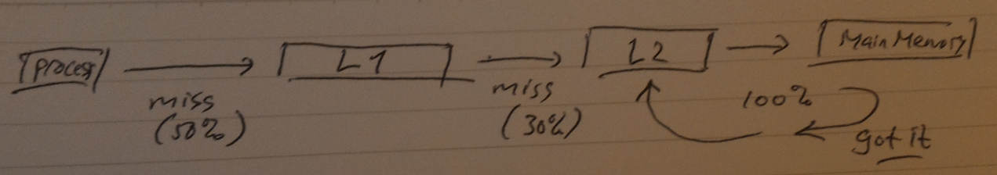

$$h_{c} \left(L2\right)=\left(1- h_{c}(L1)\right)*{( 1- h}_{c} \left(L2\right))*h_{c}(M) =\frac{50}{100}* \frac{30}{100}= 15 \%$$

1. Miss rate = $100\%-h_{c}\left(L2\right)=30\%$

Miss time (L2) = $\left(Miss rate(L2)\right)*T_{m}=0.3*200 cycles= 60 cycles$

1. Miss rate (L1) = 100% - 50% = 50%

Miss time (L1) = ${(1-h}_{L1})*h_{L2}*T_{L2}+Miss time \left(L2\right)=\left(0.5*0.7*15\right)+60=65.25 cycles$

1. Access Time in Main memory (-10%) = $0.9*200=180 cycles$

Miss time (L2) = $\left(Miss rate(L2)\right)*T_{m}=0.3*180 cycles= 54 cycles$

Miss time (L1) = ${(1-h}_{L1})*h_{L2}*T_{L2}+Miss time \left(L2\right)=\left(0.5*0.7*15\right)+54=59.25 cycles$

Improvement = $\frac{65.25-59.25}{65.25}*100\%=9.3\%$ (6 cycles lesser)

1. L1 -> 75% Hit rate, no L2

Miss time (L1) = ${(1-h}_{L1})*h_{m}*T_{m}=0.25*1*200=150 cycles$

It is possible, but performance-wise and price-wise no. Performance drop reaches almost 3x and it will cost more when it’s upgraded rather than adding a second or third level cache

$t_{eff}= h_{L1}* T_{L1}+\left(1- h_{L1}\right)*h_{L2}* T_{L2}+\left(1- h_{L2}\right)* h_{m}* T_{m}$

$$t_{eff}= 0.5*2+\left(1-0.5\right)*0.7*15+\left(1-0.7\right)*1*200$$

$$t_{eff}= 1+0.0525+60=61.0525 cycles$$

# Task 1.2

1. Diff #1: CPU caches can be accessed much faster than main memory

Diff #2: CPU caches have much lesser storage capacity than main memory

Cache Line is the way the data in the cache is organized. When a process requests a certain data from cache, the entire data in that cache line, where the process access the data, is brought up to the process.

**for** i **=** 0 **to** n **do**

read B**(**i**,**j**)** **//[1]**access cache

**for** j **=** 0 **to** n **do**

read A**(**j**,**i**)** **//[2]**access memory

B **(**i**,**j**)** **+=** A **(**j**,**i**)** **//**arithmetic operation

end **for**

write B**(**i**,**j**)** **//[3]**write **to** cache

Access is not consecutive, Access[2] jumps from 1 cache line to the other.

$T\left(n\right)=2nT_{c}+ n^{2}{(T}_{a}+T_{m})$

1. If Matrix A is stored column wise, matrix A will only fetch 1 cache line for all iteration in inner loop.
$$T\left(n\right)=2nT_{c}+ n{(nT}_{a}+T_{m})$$

2. Row-wise Matrix A = $2nT_{c}+ n^{2}{(T}_{a}+T_{m})$ = $16nT_{a}+ n^{2}{(T}_{a}+80T_{a})$

= $nT_{a} (16+ 81n)$

Column-wise Matrix A = $2nT_{c}+ n{(nT}_{a}+T_{m})$ = $16nT_{a}+ n{(nT}_{a}+80T_{a})$

= ${nT}_{a} (96+ n)$

Comparison = $\frac{T\left(n\right)for row-wise M_{A}}{T\left(n\right)for col-wise M_{A}}= \frac{81n+16}{n+96}$ ≈ 80 x

Which means, if $M_{A}$ is stored column-wise, it will be 80x faster

# Task 1.3

$Speedup= \frac{T_{total} (1)}{\frac{T_{parallel}(1)}{p}+ T_{serial}(1)}$

$Speedup= \frac{T_{total} (1)}{\frac{(1- α)T_{total}(1)}{p}+ {αT}_{total}(1)}$ with α = the part of code that can’t be parallelized

$$Speedup= \frac{T_{total} (1)}{\frac{(1- 0.1)T_{total}(1)}{16}+ {0.1T}_{total}(1)}$$

$Speedup= \frac{T_{total} (1)}{0.05625.T_{total}(1)+ {0.1T}_{total}(1)}$ = $\frac{T_{total} (1)}{0.15625.T_{total}(1)}$ = 6.4 x

1. $10= \frac{T_{total} (1)}{\frac{(1- α)T_{total}(1)}{16}+ {αT}_{total}(1)}$ = $\frac{T_{total} (1)}{\frac{\left(1- α\right)T_{total}\left(1\right)+16{.α.T}_{total}(1)}{16}}$ = $\frac{16.T_{total} (1)}{\left(1- α\right)T_{total}\left(1\right)+16{.α.T}_{total}(1)}$

$$10= \frac{16.T_{total} (1)}{\left(1- α+16α\right)T_{total}\left(1\right)}= \frac{16}{\left(1- α+16α\right)}$$

$$10\left(1+15α\right)=16$$

$$1+15α=1.6$$

$$15α=0.6 ; α=0.04$$

Which means, 96% of the code must be able to operate parallel (only 4% is allowed for serial process)

# Task 1.4

1. Speedup means how much faster can the code run in parallel compared in serial form

Efficiency means the comparison between the speedup obtained in parallelism with the number of processors used

r **=** MIN_INT **//**r**=**result

**for** i **=** 0 **to** n **do**

read **(**x**[**i**])**

**if** **(**max**(**r**,**x**[**i**])** **==** x**[**i**])** **//**max function **->** k

r **=** x**[**i**]** **//**arithmetic opr **->** k

**endif**

end **for**

write**(**r**)**

Steps required = $2kn$, where k = the arithmetic operation and max function

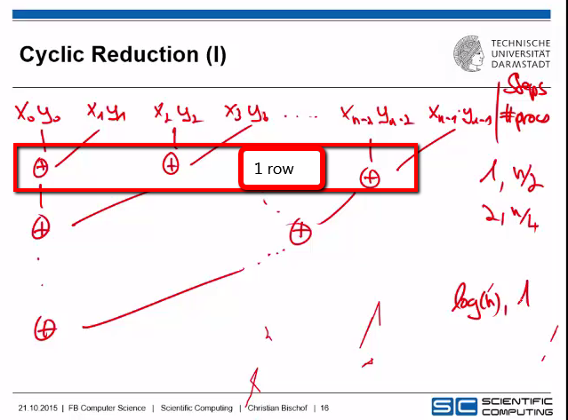

Each processor will require $2k$ steps

By taking that $\sqrt[2]{p} ∈R$ and $p= \frac{n}{2}$, The number of processors required every row*- $n$ = $\log_{2}{n}$

Total steps = $2k\log_{2}{n}$

*\*1row is 1 calculation cycle*

$Speedup= \frac{2kn}{2k\log_{2}{n}}= \frac{n}{\log_{2}{n}}= \log_{n}{2^{n}}= \log_{2p}{2^{2p}= }\log_{2p}{4^{p}= p{.log}_{2p}4}$

$Efficiency= \frac{Speedup}{p}=\log_{2p}4$

1. With $n= p^{2}$;

$$Speedup= \frac{p^{2}}{\log_{2}{p^{2}}}=\frac{1}{2}p^{2}. \log_{p}{2}$$

$$Efficiency=\frac{1}{2}p. \log_{p}{2}$$